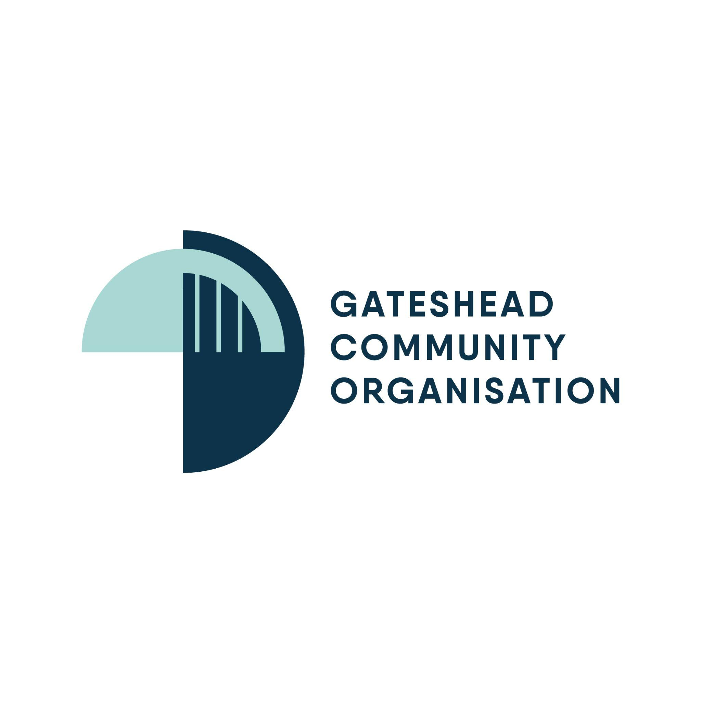
Gateshead Cafe of Opportunity
Callendar Court, Beacon Lough NE9 6RR
Please pre order 07548834751

Week 1 | Monday | Tuesday | Wednesday | Thursday | Friday
 | Corned beef hotpot | Mince & Dumplings served with potatoes and fresh vegetables | Toad in the hole-  Sausage baked in a crispy Yorkshire pudding served with seasonal veg | Chicken pie served with potatoes and fresh vegetables | Homemade battered fish/Scampi triple cooked chips and Mushy Peas
 | Chocolate Cake | Crumble & Custard | Rice Pudding | Sponge Cake | Eton Mess

Week 2 | Monday | Tuesday | Wednesday | Thursday | Friday
 | Chicken Casserole served with parsley potatoes and seasonal greens | Cottage pie served with seasonal vegetables | Fresh Salmon in butter sauce served with new potatoes | Corned beef pie served with creamed mash and fresh vegetables | Homemade battered fish/Scampi triple cooked chips and Mushy Peas
Dessert | Chocolate cake | Crumble & Custard | Rice Pudding | Sponge Cake | Eton Mess

Week 3 | Monday | Tuesday | Wednesday | Thursday | Friday
 | Cumberland sausage served with mash potato, seasonal veg and onion gravy | Mince & Dumplings served with mash and fresh vegetables | Smoked Haddock served with broccoli and cauliflower with cheese sauce new potatoes | Meat pie served with creamed mash potato and seasonal veg | Homemade battered fish/Scampi triple cooked chips and Mushy Peas
Dessert | Chocolate Cake | Crumble & Custard | Rice Pudding | Sponge Cake | Eton Mess

Weekends | Option 1 | Option 2 | Dessert
Saturday | Brunch/All day Breakfast  Bacon sausage fresh tomato baked beans egg mushroom and hash brown | Jacket Potato with a choice of fresh fillings & side salad or choice from daily menu | Cheesecake
Sunday | Roast dinner with choice of Meat with Yorkshire puddings and seasonal vegetables | Jacket Potato with a choice of fresh fillings & side salad | Trifle

Panninis | Sandwiches | Homemade Soups | Jacket Potato
Tuna Melt | Tuna Mayonnaise | Roasted Pepper | Tuna Mayonnaise
Mozzarella and Red Onion | Cheese Savory | Tomato and Basil | Cheese
Ham And Cheese | Ham & Pease Pudding | Leek and Potato | Beans

All meals cost £6.50 including dessert
Vegan, Halal alternatives available

